

C0308 – Circuit Reference Custom Field Specification
(Also included -CO309 – Circuit Reference Report)

This document has been approved by

Benjamin Timberlake | Laurence Chapman
Business consultant | Solution owner or accountable role
09/12/2020 | 5th Jan 2021
Date | Date

Document Revision History
Revision | Date | Author | Remarks
B1 | 2020-12-01 | BIAHSE | Released as Template
B2 | 2020-12-01 | BIAHSE | Released as Version
A1 | 2020-12-09 | BETICV | Custom Field Specification Written – First Revision
A2 | 5th Jan ‘21 | LACH | CO308 up-revised to A2, CO309 also included

Table of Contents
1 Purpose and Guidance 4
2 Open Issues/Decisions Required 5
3 Business Requirements and References 6
4 Solution Description 7
4.1 Description 7
4.2 Custom Field Requirement 8
5 Delimitations 9
6 Translations 10
7 Go Live Information/Upgrade Issues 11
8 Performance Considerations 11
9 Glossary/Acronyms 12
10 Change log 13
10.1 Change log for revision XX 13

Purpose and Guidance
This document specifies how the defined functions shall be developed or how the application shall be customized to solve the business requirements.

The Solution Description defines what will be delivered. The solution is matched against the requirements described in the Requirements section.
The Delimitations describe what is explicitly not covered by this customization. Together with the Solution description, these sections delimit the extent of the functional addition agreed for implementation.

Open Issues/Decisions Required
This specification cannot be completed until the following issues/decisions have been resolved:
Issue/Decision | Responsible

Business Requirements and References
Business requirements, references, sources and relations to other customizations are defined in Business requirement specification:
Document No | Rev | Document Name | Comments
CO309 |  | Circuit Reference Report | This CO309 has been included in this up-revised to A2 CO309 as these Customisations are so closely related, LC, 5/1/21

Solution Description

Description
Tunstall are required to capture the Circuit Reference information for each Engineering Part. The original plan was to utilize the Drawing Position No however this field has a limit of 10 characters and Tunstall recognize that there are instances where the result will need to display more characters than this as exampled below.

Example: R001, R002, R056, R921

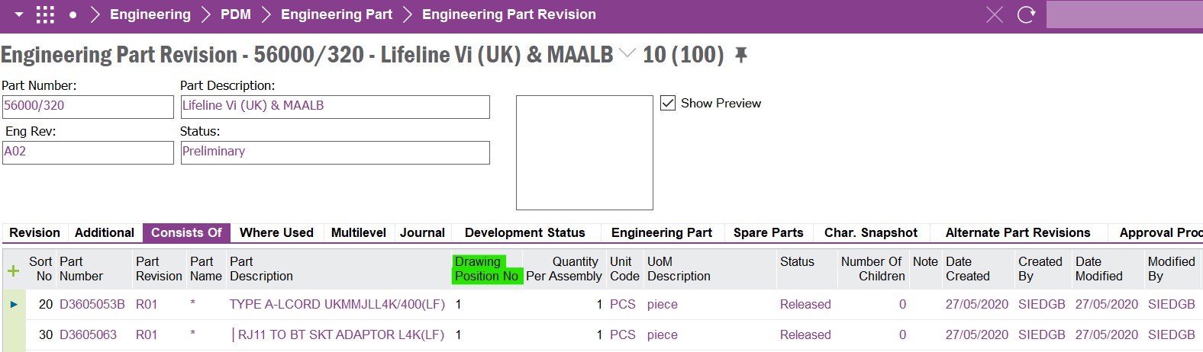

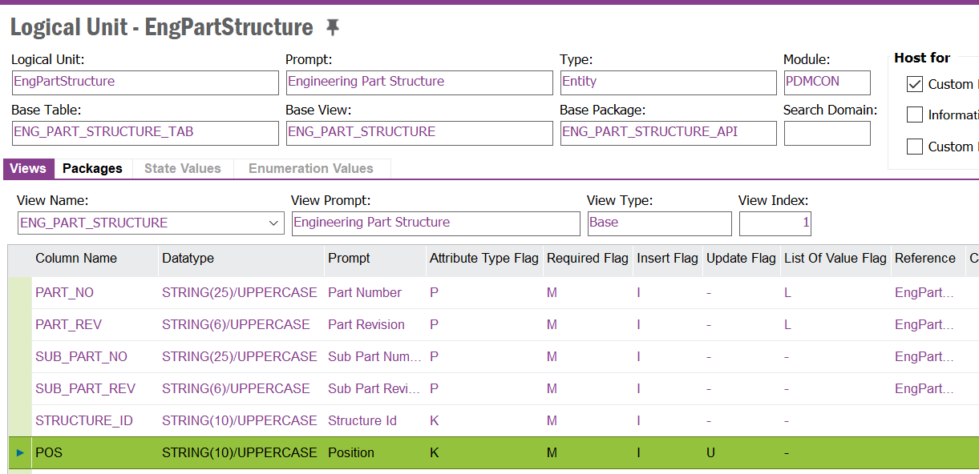

What is required is a free text custom field on the Consists Of tab that goes to a 1000-character limit.
(Any text above this sentence drafted by Ben Timberlake, any text below by Laurence Chapman, LC, 5/1/21)

Further Specification as per Revision A2:

Revision A1 of this specification itemized custom DB column CIRCUIT_REF to be placed in the Lines of Engineering Part Revision>Consists Of. This custom column is also to be copied in to the Lines of Product Structure>Product Structure>Components. These two columns will be identical after initial database migration and Go Live. Thereafter, the column in Product Structure>Product Structure>Components will be updated by the up-revisioning of the Product Structure by the normal update effected by the Direct Transfer action of Engineering Revision Transfers.

Further Specification as per CO309 – Circuit Reference Report:

A Circuit Reference Report is required specifying the code of the Circuit Reference verses the Part number of that component in the Product Structure for the entire contents of that Product Structure. Hence the report would look something like this:

LINE_ITEM_NO | CIRCUIT_REF | COMPONENT_PART | Part Description
1 | R001 | S1180000 | RESISTOR 0R 1% 0W063 0402 (LF)
1 | R002 | S1180000 | RESISTOR 0R 1% 0W063 0402 (LF)
1 | R003 | S1180000 | RESISTOR 0R 1% 0W063 0402 (LF)
2 | R004 | S2204041 | CONNECTOR MULTI F 4WAY
3 | R005 | D3706008A | BATT LIION 2500mAH 18650

This repot needs to be summoned from a RMB from the header of two different screens:

- Engineering Part Revision>Consists Of
- Product Structure>Product Structure>Components

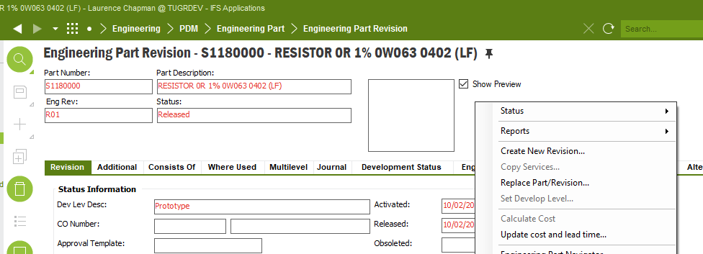

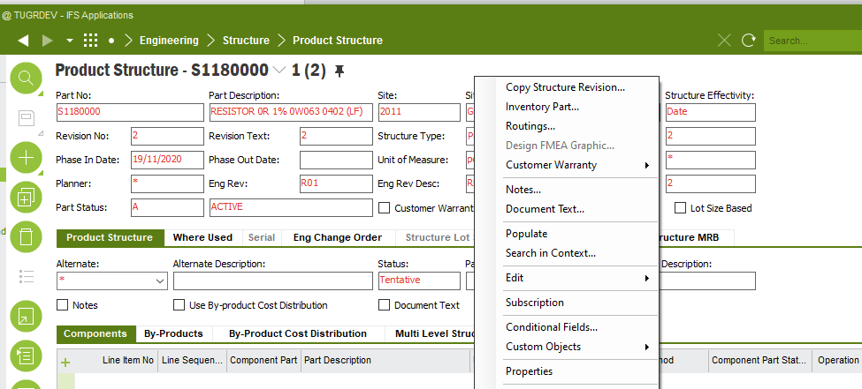

This Quick Report is to be a presented as a continuous print in pdf format on A4 portrait.

Custom Field Requirement

Field definition
DB Column Name (if known) | Field Label | Insert | Mandatory | Update | Queryable | Zoom | Uppercase | List of Value | Format & Length | Comment and Reference
CIRCUIT_REF | Circuit Reference | Y | N | Y | Y | N | N | N | VARCHAR2  (1000) | C0308 – 09/12/2020 Benjamin Timberlake

Delimitations
The modification in this specification will be developed explicitly as written. Requests for changes in the modification necessary to fulfil (or prepare for future fulfilment of) any requirements not explicitly described in the specification, will be considered outside the scope of this modification.
Translations other than stated under chapter translations are not included in the scope for this specification.
Customer IFS permission sets will be managed by the customer, unless as stated in a revision to this Functional Specification the customer requests new permission sets to be built to enable control of the customisation’s functionality.
Customer IFS profiles will be managed by the customer.
Changes or extensions on Online Help (F1 Help), e-learning material or process models are excluded from this specification.

Translations

Prog Text | Translation | Window/form (optional) | Comment

Go Live Information/Upgrade Issues
Not Applicable.

Performance Considerations
The custom field should not hinder performance in reference to decreasing user performance and screen population time.

Glossary/Acronyms
Commonly used IFS terms within this specification include:
Term | Explanation
LOV | List of Values. This refers to a source list of records from which to select in a form.
RMB | Right Mouse Button. Commonly used abbreviation

Change log
Guidance: Delete section if no changes

Change log for revision XX

Guideline: Describe why the change order is needed (high level), and the sections of design affected by the changes. For lengthy specs, tag or mark the changed sections.

Change # | Chapter | Description of the change
1
2
3
n | 3.2 | <New column Z added to existing window>

Detailed description of Change #1

Detailed description of Change #n

TECHNICAL IMPLEMENTATION
Following Custom Objects are part of this implementation;
Custom Fields:
Engineering Part Revision Window
Circuit Reference - CF$_CIRCUIT_REF
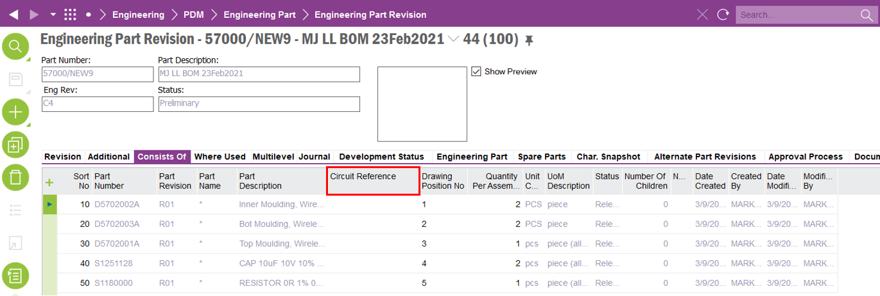
Product Structure Window
Circuit Reference - CF$_CIRCUIT_REFERENCE
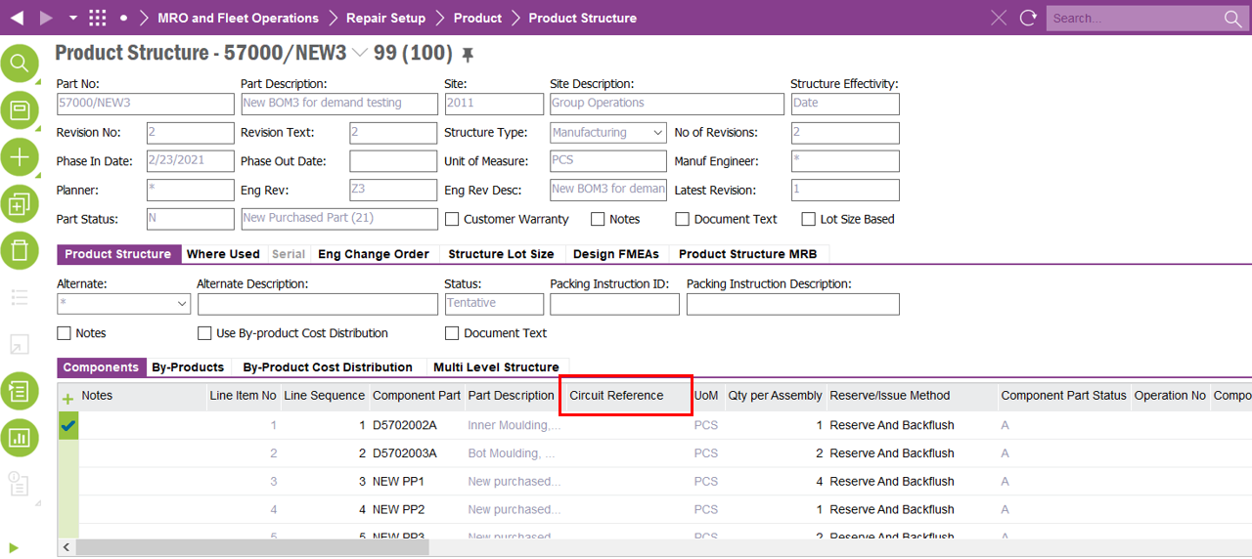

Custom Menus:
Engineering Part Revision Window
Circuit Reference Report
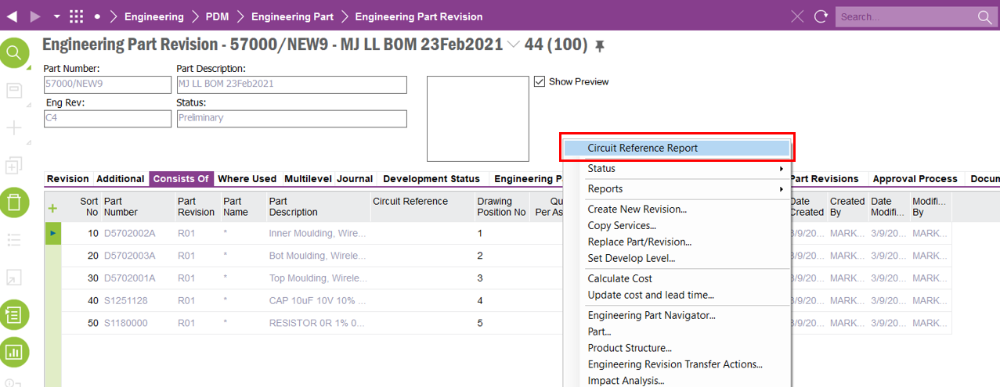
Product Structure Window
Circuit Reference Report

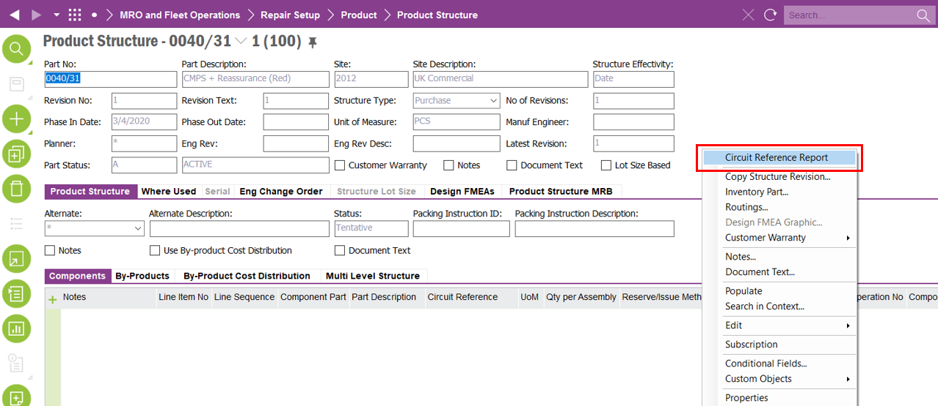

Quick Reports:
Circuit Reference Report - Eng Part Revision:
This report is connected to the ‘Circuit Reference Report’ RMB option of the ‘Engineering Part Revision’ window
Circuit Reference Report - Product Structure:
This report is connected to the ‘Circuit Reference Report’ RMB option of the ‘Product Structure’ window
Presentation Objects:
repQUICK_REPORT54791 -> Quick Report ‘Circuit Reference Report - Eng Part Revision’
repQUICK_REPORT536860 -> Quick Report ‘Circuit Reference Report - Product Structure’
Permission Sets:
Both quick reports are granted to following permission sets;
- IFS_ALL
- FND_QUICK_REPORTS

